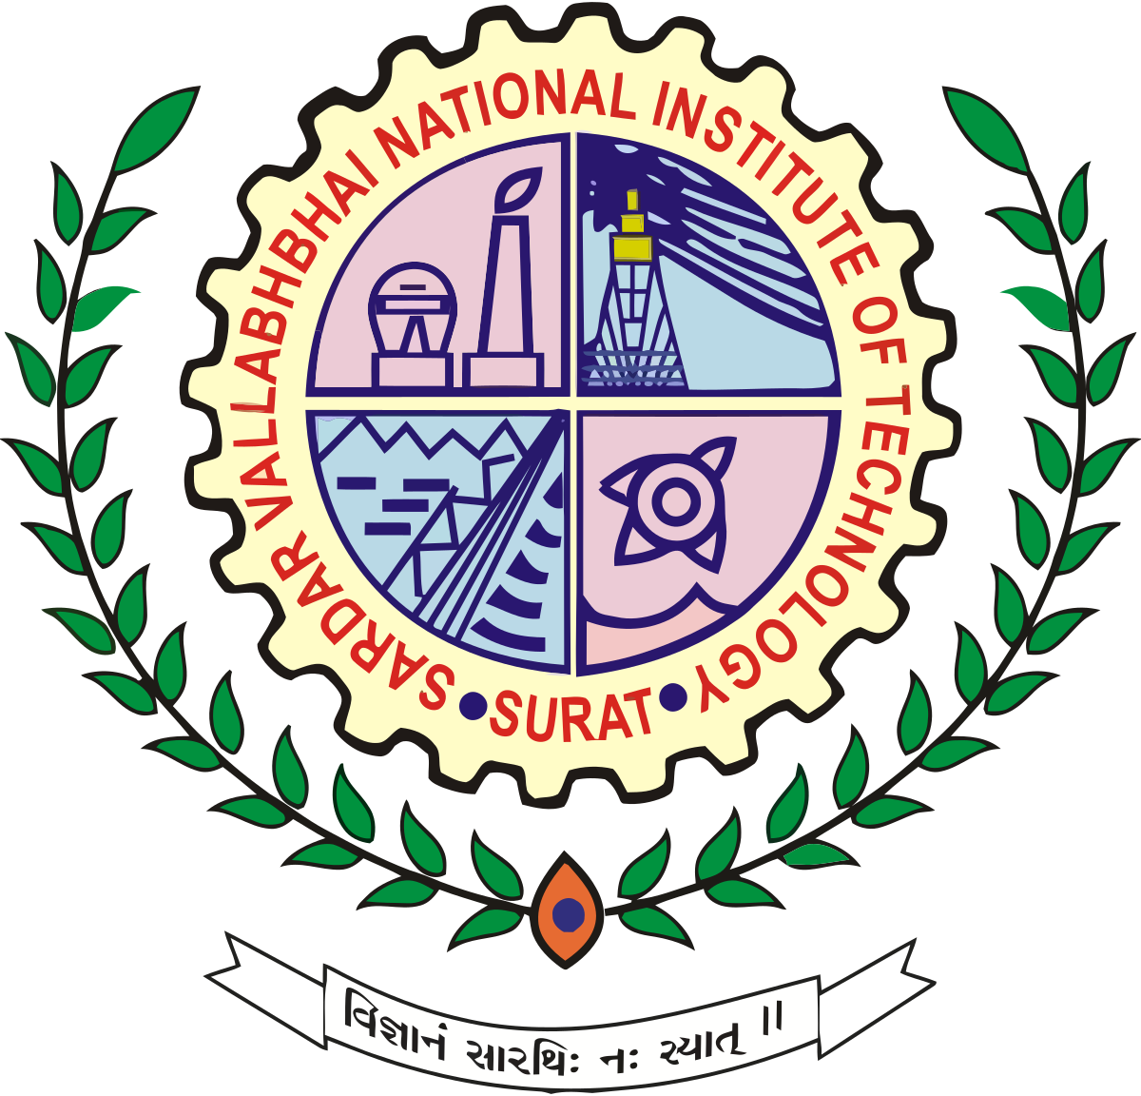
Logo of the institute
Sardar Vallabhbhai National Institute of Technology

and

Academic Institute/Industry/Research Lab

MEMORANDUM OF UNDERSTANDING

In order to promote co-operation between Sardar Vallabhbhai National Institute of Technology, hereinafter referred to as “SVNIT” and the Academic Institute Name, State (hereinafter referred to as “--------”), the two institutions agree as follows:

- The two institutions will encourage direct contact and co-operation between their faculty and administrative staff, departments and research institutions.

- Within mutually acceptable fields, the following general forms of co-operation for programmes or activities will be explored for potential negotiation:

- Visits by and exchanges of faculty members and research scholars

- Exchange of information including, but not limited to, research publications of faculty members

- Joint research activities and joint supervision of research work

- Joint conferences or symposia on subjects of mutual interest

- It is agreed that the terms and conditions of any agreed programme and activity contemplated in this MoU shall be the subject matter of separate written agreements to be negotiated and agreed upon by both Parties and/or any third parties, wherever applicable. PROVIDED ALWAYS, the decision whether to initiate and/or implement any programme or activity shall be at each party's sole discretion.

- This memorandum is not intended to create binding or legal obligations on either party. It merely expresses the intentions and understanding of the Parties, which will form the basis of any legally binding agreement to be drafted and executed in the future.

- Both parties understand and agree that this memorandum creates no financial obligations on either party, and all financial arrangements will have to be negotiated and will depend on the availability of funds.

- The Parties agree and undertake to keep confidential at all times any confidential information or data that may be exchanged, acquired or shared in connection with any programme or activity conducted pursuant to this MoU save where the same is already in the public domain, obligated by law or otherwise defined in any subsequent agreement on the subject matter.

- This MoU shall have an initial term of two years ending on (dd/mm/yyyy) and will be renewed for another period of one/two/three years’ term after reviewing the activities performed under this MoU unless written notice by one party to another party for not renewing the MoU is given not later than one (1) month before the expiry of the current term. This MoU may be terminated at any time by mutual written consent or by three (3) months' notice in writing by either party.

- Every notice, request or any other communication required or permitted to be given pursuant to this MoU shall be in writing, in English and delivered personally or sent by registered or certified post via airmail or by courier or email (which shall be acknowledged by the other Party) to the Parties at the addresses stated below:

Sardar Vallabhbhai National Institute of Technology, Ichchhanath, Surat-395007, Gujarat, India.

Attention:
Prof.__________________
Position: Director
Email: director@svnit.ac.in

<Institute name and address)

Attention:
Name: ________________
Position: ______________
Email: _________________

IN WITNESS THEREOF, the Parties have caused this MoU to be executed by their duly authorized representatives.

For and behalf of For and behalf of
SVNIT, Surat The Academic Institute

_____________________________ _____________________________
Prof. _________________ Name:_______________________
Position: Director, SVNIT, Surat Position: ____________________
Date: ________________________ Date: ________________________

Witness 1. ________________  2. ________________ | Witness 1. ________________  2. ________________

